

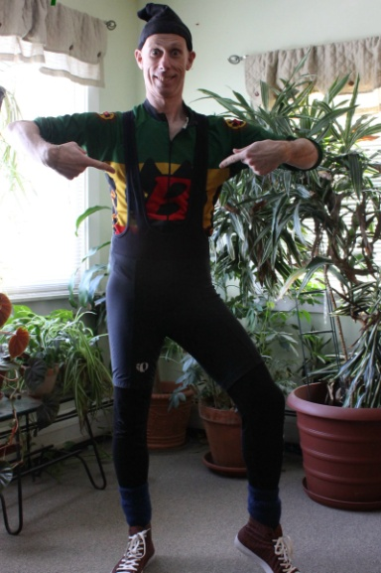
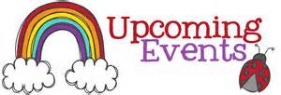
The Pawlet Library’s 48th Annual Book Sale

Saturday July 25th 9-3
Sunday July 26th 10-2pm
@
Mettawee Community School

Books, DVDs, CDs, videos, puzzles,
games, toys and more.
On Tuesday July 21st
The Pawlet Vol. Fire Department
Will be joining our story time from 10-11am
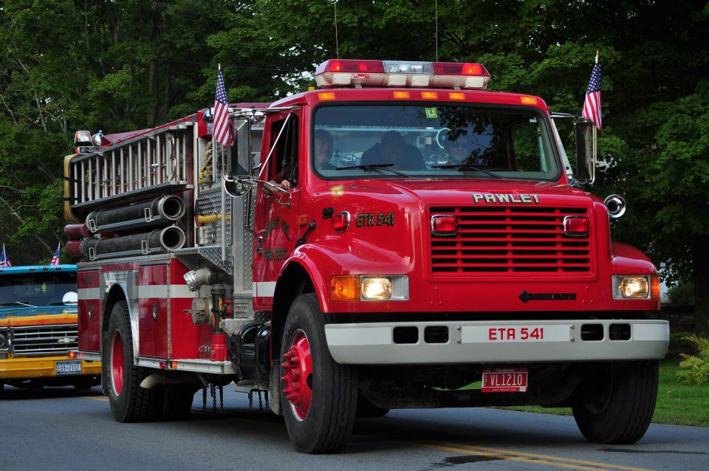
Meet K9 Buck
&
Trooper Duca
July 14th 10-11am
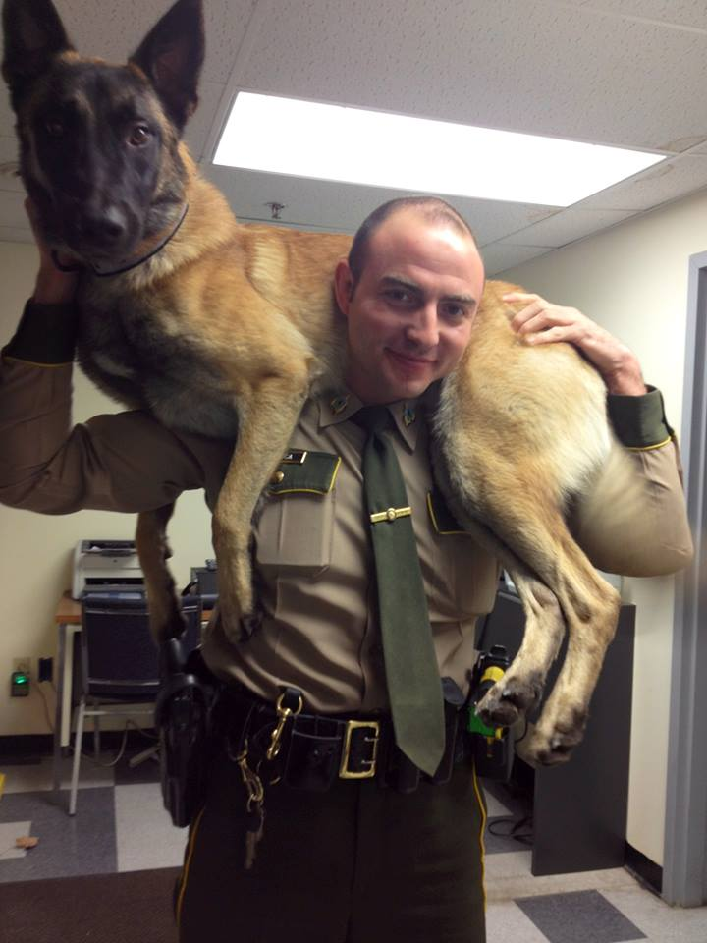

Join our DCF Book Club on
Thursday June 25th
5:30-7:00pm

Gabriel Finley & the Raven’s Riddle
Book Discussion
Trivia/Jeopardy
Book Related Activity
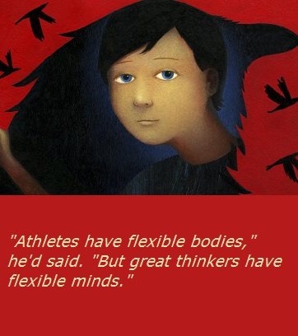
Come one, come all

- Hear amazing stories about heroes from around the world and right here in Vermont.
- Be inspired to find your inner hero!
- Receive practical instruction on how everyone can be a hero.
- Magic tricks & stunts!!
- Fitness tips!
- Create your very own heroic name!
Peter Burns
will kick off
The
Pawlet Public Library’s
Summer Reading Program

Tuesday June 23rd
From 10-11:00am

Happening
at
The Pawlet Public Library

141 School St.
Pawlet, VT

